Case 8-A478-Can-Vancouver Is-Kwakwaka'wakw-Grizzly Bear Plaque-Wood-1960

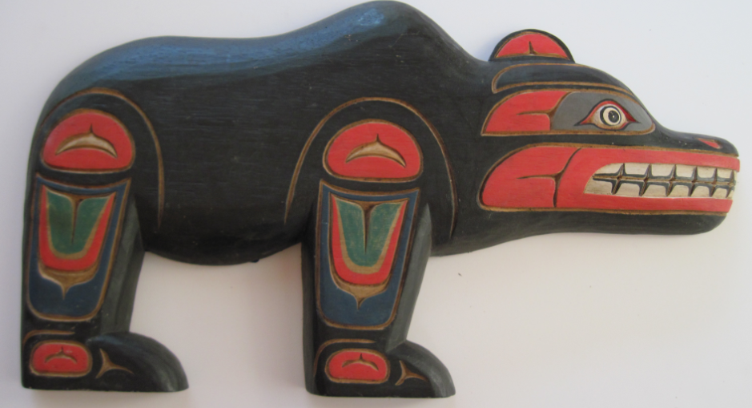

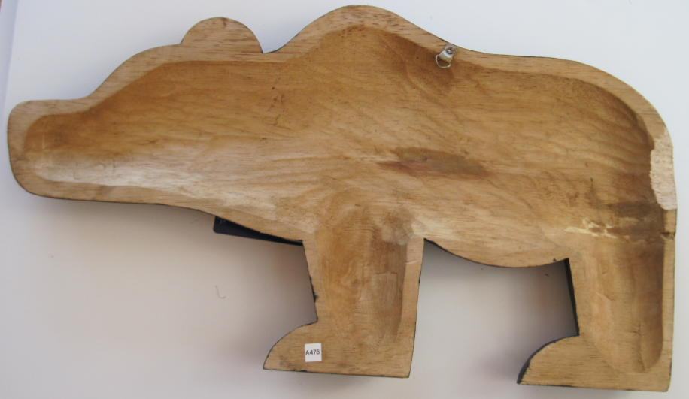

Figs. 1-2. Can-Vancouver Is-Kwakwaka'wakw-Grizzly Bear Plaque-Wood-1960

**Case no.: 8**

**Accession Number:**

**Formal Label:** Can-Vancouver Is-Kwakwaka'wakw-Grizzly Bear Plaque-Wood-1960

**Display Description:**

The grizzly bear, Nan, or Gala is the most dangerous and fearsome animal known to the Kwakwaka'wakw. Even the powerful killer whale, although having canoe travelers almost entirely at his mercy, is ordinarily not aggressive toward them. It is no wonder that the great bear is an important crest animal on the Northwest Coast and that he appears prominently in the art. In Kwakwaka'wakw ceremony Nan appears in both major ritual complexes, the ˜se…a and the T'‡asala.

**LC Classification**: E99.K9

**Date or Time Horizon:** 1960

**Geographical Area:** Fort Rupert, northeastern Vancouver Island.

**Map, GPS coordinates:** 50º41'51.16" N 127º25'32.09" W

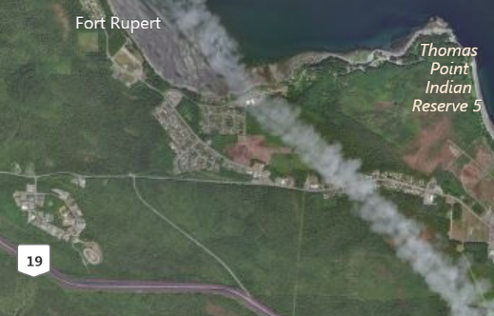

Fig. 3. Map of Fort Rupert and the Kwakwaka'wakw Reserve. After www.bing.com

**Cultural Affiliation:** Kwakwaka'wakw, Kwagu’ł band living at Fort Rupert

**Media:** Wood, red and black paint.

**Dimensions:** **Weight:**

**Condition: original**

**Provenance:** artist

**Description:**

Dance and Regalia:

Nan dances upright in a swaying motion displaying his claws and waving them around for all to see, recreating the lumbering movements of the dangerous and fierce grizzly bear. His characteristic poses and his movements are reproduced convincingly in dramatic dance form.  
  
Some families also wear the bear hide as a cape during the tamed hama‰sa. He may wear a complete costume of grizzly hide with the head becoming a mask or will use a carved wooden mask attached to the hide. When unmasked, the grizzly dancer wears cedar bark ornaments with mitten-like paws of a bear or made up of fur with long wooden claws.

The Grizzly Bear dance is a high-ranking dance originating from the 'Nak'waxda'xw of Ba'as or Blunden Harbour. The members of the Nan society kept order during the hama‰sa ceremony, working together with the Nu‡ama‡. In earlier days the initiates of the Nan society were authorized to punish with death those who behaved inappropriately during the hama‰sa ceremony.  
  
The grizzly bear dancer and the nu‡ama‡ worked together in this capacity; both were powerful helpers of the hamat'sa during the Winter Ceremony.  
  
The initiate into the society sought to frighten the audience with his potential power, as his role in the ceremony was to act as a policeman enforcing proper behavior. Another responsibility was to guard the ceremonial house.

The rôle of the past is still evident in the conservatism among some sculptors who refer to the masks and plaques of the past in their work. In this respect, masks are highly valued by the Kwakwaka'wakw as manifestations of ancestral spirits and supernatural beings. These supernatural entities are embodied through dance performance (Greenville 1998: 14). However, Northwest Coast tribes vary in their use of different myths, characters, and masks (Malin 1978: 47). Since each mask and accompanying dance programs are “owned” by particular families and passed down by elders and chiefs to their immediate and extended families, they have a certain conservatism in their presentation in the potlatch and seasonal festivals, accruing histories that incrementally transform their meaning (Gosden and Marshall 1999: 172), which is reflected in the way sculptors create new masks based on these transformations (Malin 1978:18-19; Ostrowitz and Jonaitis 1991: 251).

These transformations have been facilitated by Fort Rupert on northeastern Vancouver Island, the traditional homeland of several bands of Kwak’wala speakers. The Kwagu’ł band living at Fort Rupert has been considered one of the highest-ranked bands, with illustrious lineage from myth time to the present and important chiefs. Their home is a site of strong traditional ceremonialism. In 1849, the Hudson's Bay Company established a trading fort there, thus promoting Fort Rupert as a center for commerce and as the most prominent village during the last half of the nineteenth century ideas for transforming masks were freely flowing. George Hunt, of Tlingit and Scottish ancestry (his father was a factor at the fort) but raised in Kwakwaka’wakw traditions, collected valuable information and hundreds of utilitarian and ceremonial objects for museums beginning in the 1890s.

**References:**

Greenville, Bruce. 1998. “Introduction.” In Macnair, et al. 1999, pp. 14-16.

Hawthorn, Audrey. 1979. *Kwakiutl Art*. Seattle: University of Washington Press.

Holm, Bill. 1984. *Form in Northwest Coast Art in Indian Art Traditions of the Northwest Coast*, ed. Roy L. Carlson. Burnaby, B.C.: Archaeology Press & Simon Frasier University.

1972. *Crooked Beak of Heaven*. Seattle: University of Washington Press.

1965. *Northwest Coast Indian Art*. Seattle: University of Washington Press.

Boas, Franz; George Hunt. 1902-1905. *Kwakiutl texts, First and Second Series*. Memoirs of the American Museum of Natural History, v. 14, pt. 1; Publications of the Jessup North Pacific Expedition, v. 10, pt. 1. New York: Knickerbocker Press

Jonaitis, Aldona; Douglas Cole; Stacy Alyn Marcus; Lynton Gardiner. 1991. *Chiefly Feasts: The creation of an exhibition in Chiefly Feasts: The Enduring Kwakiutl Potlatch.* New York and Seattle: American Museum of Natural History and University of Washington Press.

Macnair, Peter. 1998. *Power of the Shining Heavens in Down from the Shimmering Sky: Masks of the Northwest Coast.* Vancouver and Seattle: Douglas & McIntyre and University of Washington Press.

Macnair, Peter; Robert Joseph; Bruce Grenville. 1999. *Down from the Shimmering Sky: Masks of the Northwest Coast.* Vancouver, British Columbia: Dover.

Malin, Edward. 1999. *Northwest Coast Indian Painting: House Fronts and Interior Screens*. Portland, OR: Timber Press.

1978 *A World of Faces: Masks of the Northwest Coast Indians*. Portland, OR: Timber Press.

Masco, Joseph.1995. “‘It is a Strict Law That Bids Us Dance’: Cosmologies, Colonialism, Death, and Ritual Authority in the Kwakwaka'wakw Potlatch, 1849 to 1922,” *Comparative Studies in Society and History* 37 (1): 41-75.

Ostrowitz, Judith, and Jonaitis, Aldona. 1991. “Postscript: The Treasures of Siwidi in Chiefly Feasts: The Enduring Kwakiutl Potlatch” In Aldona Jonaitis, et al., 1991.

Pollock, Donald**.** 1995. “Masks and the Semiotics of Identity,” *The Journal of the Royal Anthropological Institute* 1(3): 581-597.